Smart Agriculture Monitoring using Node-Red

Yogesh P  
Electronics and Communication and Engineering  
VIT - ChennaiChennai, India  
yogesh152003@gmail.com

Varun G  
Electronics and Communication and Engineering  
VIT - ChennaiChennai, India  
varu6171@gmail.com

D V Mithilesh Reddy  
Electronics and Communication and Engineering  
VIT - ChennaiChennai, India  
dvmithileshreddy@gmail.com

*Abstract*— This project demonstrates the integration of an Arduino microcontroller with Node-RED, a visual programming tool, to create a comprehensive environmental monitoring system. The system collects data from various sensors, including a DHT11 temperature and humidity sensor, an LDR (light-dependent resistor) for ambient light monitoring, an MQ135 gas sensor for air quality detection, and a soil moisture sensor. The Arduino board gathers the sensor data and transmits it to a Node-RED flow running on a computer or a Raspberry Pi. Node-RED processes the incoming data and displays it on a web-based dashboard, providing visual representations such as gauges for each sensor reading. Additionally, the system sends an email notification with the sensor data to a pre-configured email address. Furthermore, the project utilizes the SimplePush node in Node-RED to send push notifications to the user's mobile device, alerting them to changes in the monitored environmental conditions. This integrated system allows for real-time monitoring, data logging, and remote notification, making it a versatile solution for applications such as home automation, agricultural monitoring, or industrial control. The key aspects of this project include the seamless communication between the Arduino and Node-RED, the dynamic visualization of sensor data, the automated email notifications, and the mobile push notifications, demonstrating the power of combining hardware and software technologies to create a comprehensive environmental monitoring system.

Keywords—component, formatting, style, styling, insert (key words)

# Introduction

The increasing demand for smart home and environmental monitoring technologies has driven the development of integrated systems that leverage the capabilities of microcontrollers and visual programming platforms.[2] Arduino, an open-source electronics platform, and Node-RED, a flow-based programming tool, present a powerful combination for creating such systems. This project explores the integration of an Arduino-based sensor network with a Node-RED-powered monitoring and notification system to address the need for comprehensive environmental monitoring and data visualization. [3] Environmental monitoring is crucial in various domains, including home automation, agriculture, and industrial applications. Factors such as temperature, humidity, air quality, and soil moisture play a vital role in maintaining optimal conditions and ensuring the well-being of people, plants, and processes. [5] Traditional monitoring systems often rely on standalone devices or complex software solutions, which can be inconvenient or inaccessible for users.

In this project, we propose a seamless integration of an Arduino-based sensor network with a Node-RED-powered monitoring and notification system. The Arduino board collects data from various sensors, including a DHT11 temperature and humidity sensor, an LDR (light-dependent resistor) for ambient light monitoring, an MQ135 gas sensor for air quality detection, and a soil moisture sensor. The Arduino then transmits the sensor data to a Node-RED flow, where the information is processed, visualized, and shared with the user. The Node-RED flow provides a user-friendly web-based dashboard that displays the sensor readings in real-time using intuitive gauge visualizations. This allows users to easily monitor the environmental conditions and quickly identify any deviations from the desired parameters. Furthermore, the system automatically sends an email notification to a predefined email address, informing the user of the current sensor data.

This smart agricultural monitoring system pioneers accessibility and ease of use through Node-RED integration, democratizing advanced technology for farmers. Unlike conventional systems, it eliminates complex coding, enabling users with limited technical expertise to design and deploy solutions efficiently. [1] Additionally, its utilization of tailored agricultural sensors provides comprehensive real-time data on crucial variables like soil moisture and temperature, offering farmers a holistic understanding of their environment for optimized decision-making and resource management.

To enhance the user experience and ensure timely notifications, the project also integrates the SimplePush node in Node-RED. This feature enables the system to send push notifications to the user's mobile device, alerting them to changes in the monitored environmental conditions. This added functionality ensures that users can stay informed and responsive, even when they are not actively monitoring the system. The combination of Arduino's sensor capabilities and Node-RED's versatile programming and visualization features creates a robust and user-friendly environmental monitoring system. This project demonstrates the potential of integrating hardware and software technologies to develop comprehensive solutions that address the growing demand for smart home and environmental monitoring applications.

Compared to traditional solutions, this system offers unparalleled accessibility, scalability, and flexibility. Its reliance on open-source technologies like Node-RED reduces costs and eliminates barriers to entry for small-scale farmers. Additionally, its modular architecture allows for easy customization to suit diverse farming practices and environments. By integrating real-time data analysis capabilities, it empowers farmers with immediate insights for proactive decision-making, mitigating risks and optimizing productivity. Overall, this project represents a more accessible, customizable, and cost-effective solution for farmers seeking to harness technology for precision agriculture.

# 

# TOOLS USED

## Arduino Uno

The Arduino Uno is a widely used open-source microcontroller board that has become a staple in the world of hobbyists, makers, and students. Introduced in 2010, the Uno is based on the Microchip ATmega328P microcontroller and offers a range of features that make it an ideal platform for a variety of projects. With its 8-bit AVR microcontroller, 5V operating voltage, 14 digital I/O pins, 6 analog inputs, and a 16 MHz clock speed, the Arduino Uno provides a flexible and easy-to-use solution for those looking to explore the world of physical computing. The board's simplicity, low cost, and large community of users and resources have made it a popular choice for everything from simple LED blinkers to more complex robotic, home automation, and IoT (Internet of Things) applications. Beyond the standard Uno board, there are also several variations and compatible boards available, each with its own unique features and capabilities, further expanding the capabilities of the Arduino ecosystem.

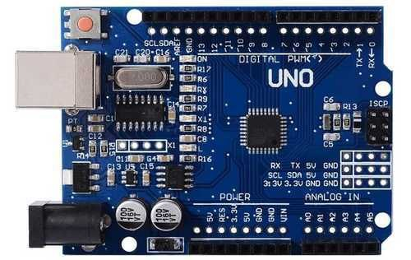

1. Arduino Uno

## DHT11

The DHT11 is a popular digital temperature and humidity sensor commonly used in Arduino and other microcontroller projects. It is a low-cost, easy-to-use sensor that can provide readings of ambient temperature and relative humidity. The DHT11 uses a capacitive humidity sensor and a thermistor to measure the surrounding air and has a measurement range of 20-90% relative humidity with an accuracy of ±5% and a temperature range of 0-50°C (32-122°F) with an accuracy of ±2°C. The sensor communicates using a single-wire interface, making it simple to integrate into various projects. It is widely used in applications such as weather monitoring, home automation, and IoT (Internet of Things) devices due to its small size, low power consumption, and readily available Arduino libraries that simplify the integration process.

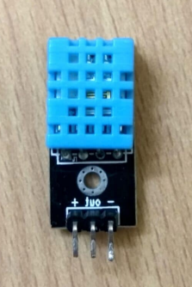

1. DHT11

## LDR

The LDR, or Light Dependent Resistor, is a type of resistor whose resistance varies depending on the amount of light incident on its surface. When exposed to light, the resistance of an LDR decreases, and when in darkness, the resistance increases. This property makes LDRs useful for a variety of light-sensing applications, such as automatic street lamps, burglar alarms, and light-activated switches. LDRs are inexpensive, simple to use, and can be easily interfaced with microcontrollers like Arduino to detect changes in ambient light levels. They are commonly used in projects that require light detection or light-based control, providing a cost-effective solution for integrating light-sensing capabilities into various electronic systems and devices.

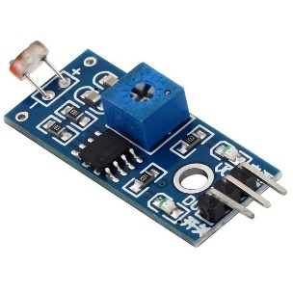

1. LDR

## Soil Moisture

Soil moisture sensors are valuable tools for gardeners and plant enthusiasts. These simple devices use the conductivity of the soil to measure its moisture content, taking the guesswork out of watering. By inserting the sensor's probes into the ground, it can provide a direct readout of the soil's water levels. The drier the soil, the higher the electrical resistance detected by the sensor, allowing you to know precisely when your plants need to be watered. Soil moisture sensors are affordable, easy to use, and incredibly useful for maintaining the optimal hydration levels for a wide variety of plants, making them an essential tool for anyone serious about keeping their garden thriving.

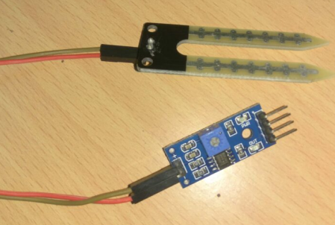

1. Soil Moisture

## MQ135 Gas Sensor

The MQ135 gas sensor is a versatile and widely used electronic device designed to detect a variety of harmful gases in the environment. This sensor is capable of sensing the presence of ammonia, nitrogen oxides, alcohol, benzene, smoke, and carbon dioxide, making it a valuable tool for air quality monitoring and control applications. By measuring the changes in the sensor's electrical resistance based on the concentration of target gases, the MQ135 can provide a digital output that can be easily integrated into microcontroller-based projects, such as air purifiers, ventilation systems, and indoor air quality alarms. With its relatively low cost, compact size, and simplicity of use, the MQ135 gas sensor has become a popular choice for a wide range of DIY and commercial applications where reliable gas detection is required.

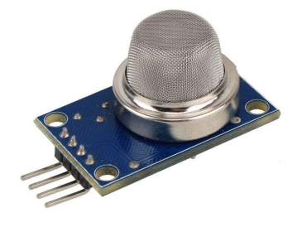

1. MQ135

## BMP180

The BMP180 is a highly accurate and versatile pressure sensor that is commonly used in Arduino and other microcontroller projects. This sensor can measure both barometric pressure and temperature, making it useful for a variety of applications such as weather monitoring, altimeter calculations, and environment sensing. The BMP180 uses a piezo-resistive pressure sensor to provide pressure readings in the range of 300 to 1100 hPa (hectopascals) with an accuracy of ±1 hPa. Additionally, the sensor can measure temperature in the range of -40°C to +85°C with an accuracy of ±1°C. The BMP180 communicates via I2C protocol, making it easy to integrate into various microcontroller-based projects. Its small footprint, low power consumption, and readily available Arduino libraries make the BMP180 a popular choice among makers, hobbyists, and professionals working on IoT and embedded systems.

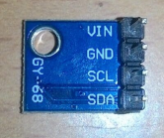

1. BMP180

## Node - Red

Node-RED is a powerful, open-source, low-code programming tool that enables the rapid development of internet-of-things (IoT) applications, automation workflows, and data processing pipelines. Designed to be user-friendly, Node-RED provides a visual interface where users can drag-and-drop pre-built "nodes" representing various functions, from data inputs and outputs to processing logic and cloud integration. This intuitive approach allows developers, hobbyists, and non-programmers alike to quickly assemble and deploy sophisticated IoT solutions without extensive coding knowledge. With a large and active community contributing custom nodes and integrations, Node-RED has become a popular choice for a wide range of applications, from home automation and industrial monitoring to data visualization and API management, making it a versatile tool for anyone looking to bring their connected ideas to life.

## SimplePush

SimplePush is a useful Node-RED node and companion mobile app that allows you to easily send push notifications to your smartphone or other devices directly from your Node-RED flows. The SimplePush node in Node-RED enables you to trigger push notifications based on events, sensor data, or other conditions in your automation projects. The SimplePush mobile app, available for both iOS and Android, pairs with the Node-RED node to receive these notifications. Setting it up is straightforward - you simply install the app on your device, generate an API key, and configure the Node-RED node to use that key. From there, you can customize the push notifications with titles, messages, and even icons. The SimplePush integration is particularly handy for home automation, IoT projects, and any scenario where you want to be alerted about important events happening in your Node-RED flows. It provides a seamless way to stay informed and in control, even when you're away from your computer. With its simplicity and flexibility, the SimplePush node and app have become a popular choice among the Node-RED community for adding push notification capabilities to a wide range of applications.



1. SimplePush Application

# SMART AGRICULTURAL MONITORING SYSTEM

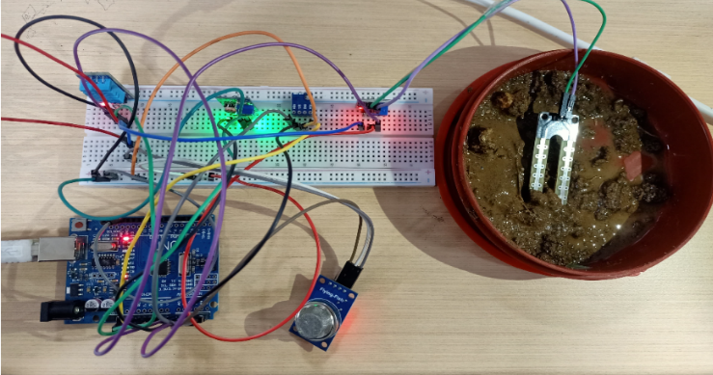This smart agriculture monitoring system leverages the integration of an Arduino Uno microcontroller and the Node-RED visual programming platform to provide comprehensive environmental monitoring and data visualization for agricultural applications. The system is designed to collect data from various sensors, process the information, and deliver real-time notifications to users, enabling them to make informed decisions and optimize agricultural practices.

## Procedure

The experiment begins by connecting the various sensors to Arduino. The DHT11 temperature and humidity sensor data pin is connected to analog pin A3 in Arduino, LDR light sensor is connected to A1 analog pin in Arduino, MQ135 gas sensor is connected to A2 analog pin in Arduino, soil moisture sensor is connected to A0 analog pin in Arduino, and the BMP180 pressure sensor SCL and SDA is connected to the A4 and A5 analog ports respectively in the Arduino Uno board. A custom code is then developed and uploaded to the Arduino Uno using the Arduino IDE, which enables the microcontroller to read and transmit the sensor data to the Node-RED flow. Once the code is uploaded, close the Arduino IDE and open Node-Red.

In the Node-RED environment, a flow is created that includes an Arduino Uno node to receive the incoming sensor data. This flow is then divided into two parallel branches: the first branch consists of a function node that processes the sensor data and connects to six gauge nodes, displaying the temperature, humidity, light level, gas concentration, and soil moisture in real-time on the Node-RED dashboard. The second branch also includes the same function node, but it is connected to an email node and the SimplePush node. This function node prepares the sensor data for both email notification and mobile push notifications.

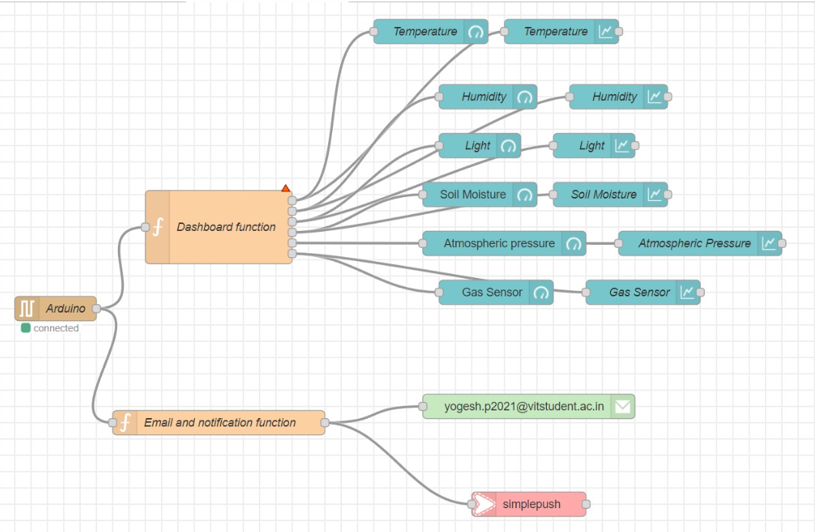

1. Node-Red Flow Diagram

Once the Arduino is connected , the function node triggers the email node to automatically send the environmental data to a predefined email address. Simultaneously, the function node formats the sensor data for mobile push notifications, which is then connected to the SimplePush node, enabling the system to send alerts to the user's mobile device. The SimplePush key from the application has to be entered into the SimplePush node to get the mobile notification.

Once the Node-RED flow is deployed, the user can access the comprehensive dashboard, receive email notifications, and get real-time push notifications on their mobile device, providing a complete smart agriculture monitoring system that combines the power of Arduino and Node-RED technologies.

## Code

* Arduino IDE Code

#include <Wire.h>

#include <dht.h>

#include <Adafruit_BMP085.h>

dht DHT;

Adafruit_BMP085 bmp;

#define DHT11_PIN A3

int chk;

int humi = 0;

int temp = 0;

int soil = 0;

int light = 0;

int gas = 0;

int BMP = 0;

boolean HT;

void setup()

{

Serial.begin(9600);

pinMode(A0, INPUT);

pinMode(A1, INPUT);

pinMode(A2, INPUT);

pinMode(A3, INPUT);

}

void loop()

{

chk = DHT.read11(DHT11_PIN);

temp = DHT.temperature;

humi = DHT.humidity;

soil = analogRead(A0);

light = analogRead(A1);

gas = analogRead(A2);

BMP = bmp.readPressure();

if (isnan(temp) || isnan(humi) || isnan(light)|| isnan(soil)|| isnan(BMP)|| isnan(gas)) //|| isnan(BMP))

{ Serial.println("Failed to read from DHT sensor!"); return; } // Combine Humidity and Temperature into single string String

String Data = String(temp) + "," + String(humi) + "," + String(100-map(light, 0, 1023, 0, 100))+"," + String(map(soil, 0, 1023, 0, 100))+"," + String(BMP)+"," + String(gas);// + "," + String(BMP);

Serial.println(Data);

delay(60000);

}

* Dashboard Function Code

m = msg.payload.split(',');

const temp = { payload: parseFloat(m[0])};

const humi = {payload: parseFloat(m[1])};

const light = { payload: parseFloat(m[2]) };

const soil = { payload: parseFloat(m[3]) };

const BMP = { payload: parseFloat(m[4])};

const gas = { payload: parseFloat(m[5]) };

return [temp, humi, light, soil, BMP, gas]

* Email and Notification Function Code

if (msg.payload) {

const m = msg.payload.split(',');

const temp = parseFloat(m[0]);

const humi = parseFloat(m[1]);

const light = parseFloat(m[2]);

const soil = { payload: parseFloat(m[3]) };

const BMP = { payload: parseFloat(m[4])};

const gas = { payload: parseFloat(m[5]) };

if (!isNaN(temp) && !isNaN(humi) && !isNaN(light) && !isNaN(soil) && !isNaN(BMP) && !isNaN(gas)) {

msg.to = "yogesh.p2021@vitstudent.ac.in";

msg.from = "noreply@gmail.com";

msg.payload = "Temperature: " + temp + "°C, Humidity: " + humi + "%, Light Intensity: " + light+ "%, Soil Moisture: "+soil+ "%, Atmospheric Pressure: "+BMP+ "Pa, Gas level: "+gas;

} else {

console.log("Error: One or more values extracted from msg.payload are not valid numbers.");

}

} else {

console.log("Error: msg.payload is null or undefined.");

}

return msg;

# SIMULATION

We will have four outputs – Arduino IDE Serial monitor, Node-Red Dashboard, Email notification and SimplePush Mobile notification. The Arduino IDE Serial monitor will display the data of the sensors in a string format. The Node-Red Dashboard has a gauge display and chart display. The gauges show the current values in their respective units and charts display the current and previous data plotted with respect to time. We get an email notification to the given mail id and a notification to our mobile with the data in text format.

## Arduino IDE Serial Monitor Output

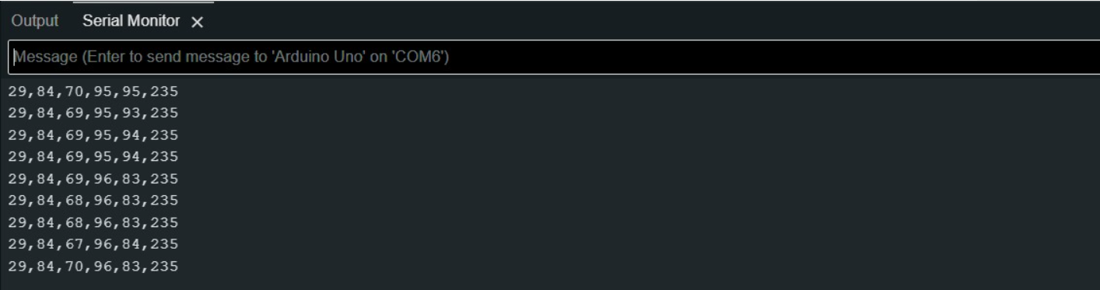

1. Serail Monitor

## Node-Red Dashboard

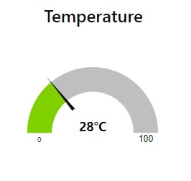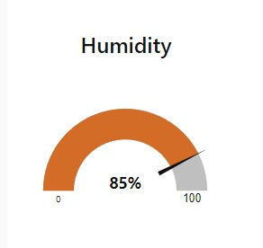

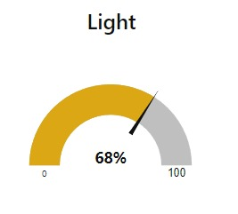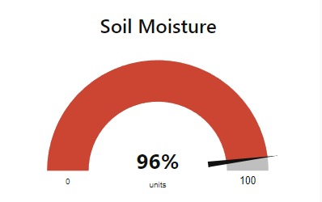

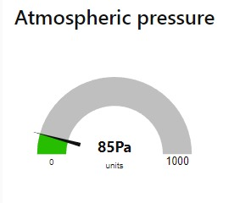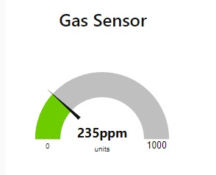

1. Gauges in Node-Red Dashboard

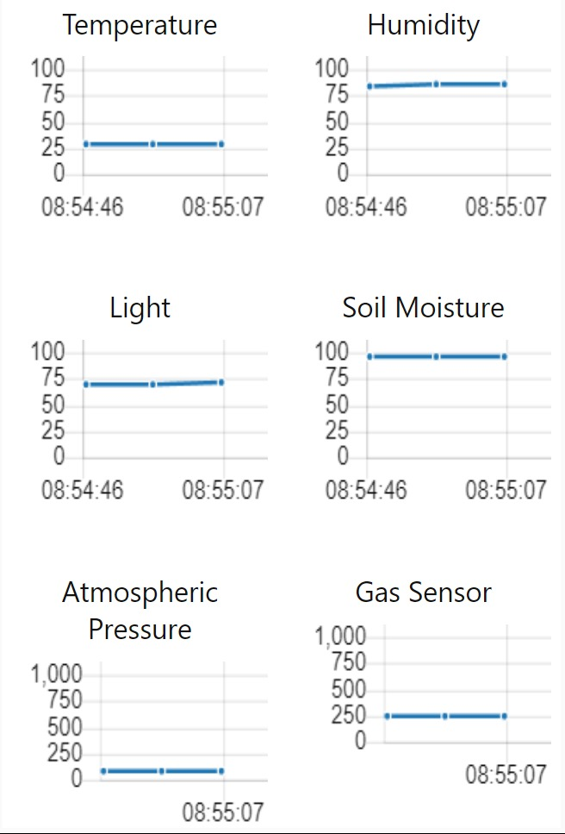

1. Graphs in Node-Red Dashboard

## Email notification

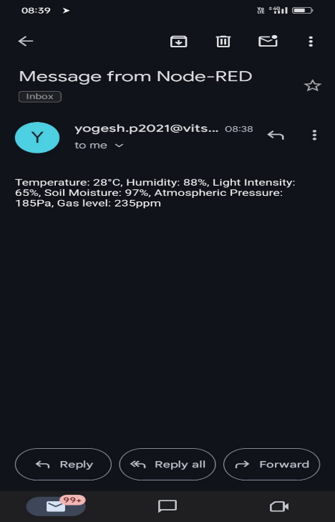

1. Email

## Mobile notification

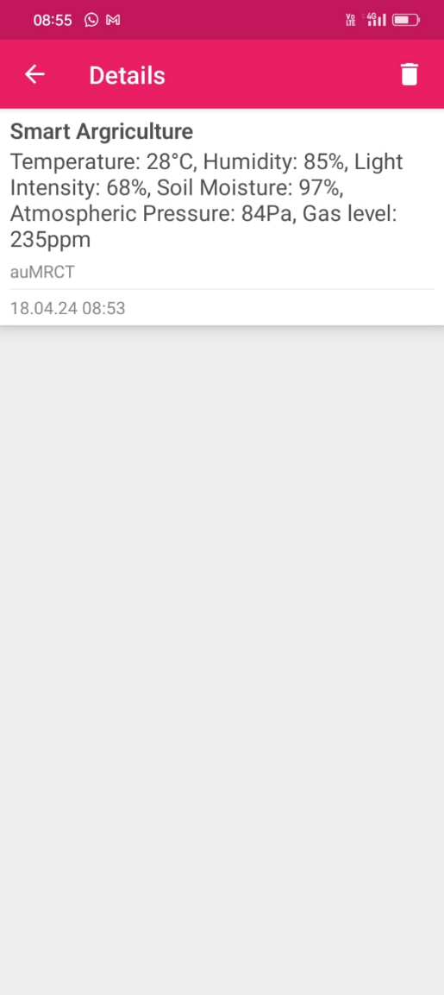

1. Mobile Notification details

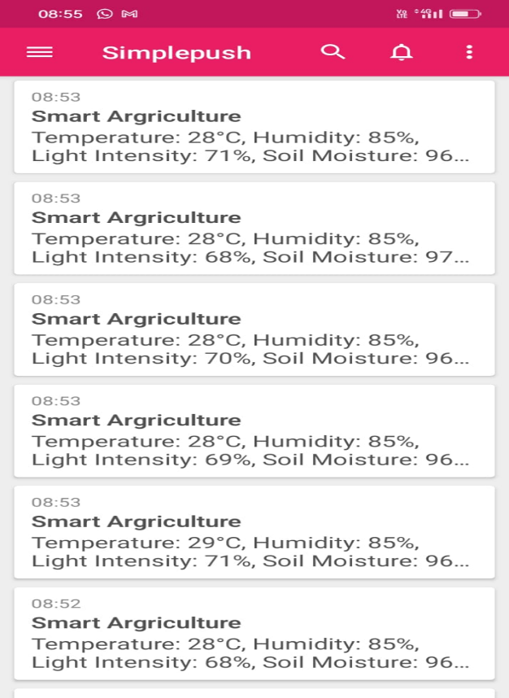

1. SimplePush Notifications

##### Acknowledgment

##### We would like to express our gratitude to Vellore Institute of Technology, Chennai and the Department of ECE for providing us this opportunity to work on this project. We are grateful to Dr. Upender P for his guidance and feedback. We also thank our lab technicians for their technical assistance. We also extend our gratitude to all those who have supported us throughout this project, including mentors and peers.

##### References

1. Banzi, M., & Shiloh, M. (2014). Getting started with Arduino: The open source electronics prototyping platform. Maker Media, Inc.
2. Blackstock, M., & Cousins, R. (2014). Node-RED: A browser-based flow editor for the Internet of Things. In 2014 IEEE World Forum on Internet of Things (WF-IoT) (pp. 369-370). IEEE.
3. Damas, M., Barrero, F., Toral, S. L., & Vargas, M. (2019). A low-cost sensor node for smart irrigation systems. Sensors, 19(14), 3027.
4. Joshi, A., Sawant, S., Joshi, R., & Bhoir, D. (2019). IoT based smart greenhouse monitoring system. In 2019 3rd International Conference on Trends in Electronics and Informatics (ICOEI) (pp. 1032-1037). IEEE.
5. Schooten, B. V., & Pereira, F. C. (2018). Connecting Arduino and Node-RED for the Internet of Things. IEEE Potentials, 37(3), 16-23.